**Wireframe Document**

**Adult Censes Income Prediction**



**Revision Number - 1.0**

**Last Date of Revision – 02-11-2022**

**ADIL ANWAR**

# Document Control

|  |  |  |  |  |
| --- | --- | --- | --- | --- |
| **Date** |  | **Version** | **Description** | **Author** |
| 02-11-2022 | 1.0 |  | WIREFRAME Document | Adil Anwar |
|  |  |  |  |  |
|  |  |  |  |  |
|  |  |  |  |  |

**We Performed Exploratory Data Analysis on Jupyter Notebook and then created Dashboard.**

**Home Page**

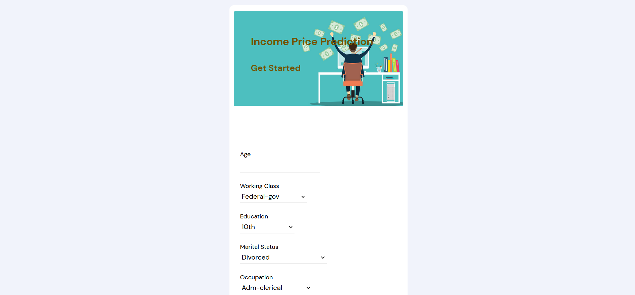

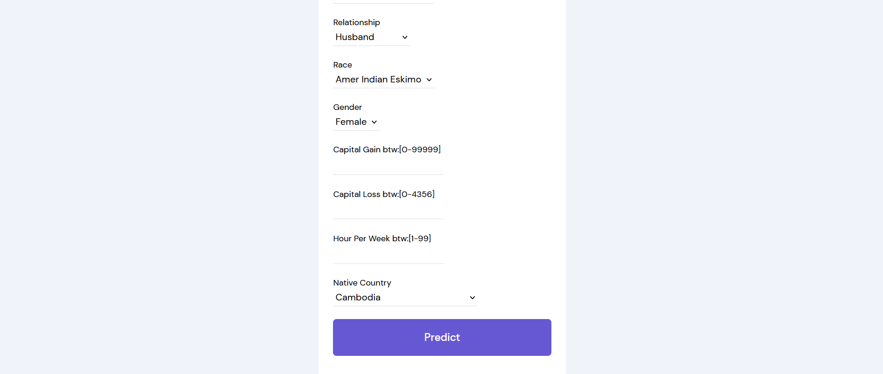

**Prediction Page**

